Assignment 4: MPI Programming Performance Analysis
Name: ADITYA CHAUHAN
Roll Number: 102303130

Exercise 1: Ring Topology Communication
Objective: Write an MPI program where each process sends a message to the next process in a ring topology. Process 0 sends to Process 1, Process 1 sends to Process 2, and the last process sends back to Process 0.

Results
Process (p) | Time Tp​ (s) | Speedup Sp​ | Efficiency Ep​ (%) | Communication (%)
1 | 0.321981 | 1.0000 | 100.00 | 0.00
2 | 0.315501 | 1.0205 | 51.02 | 48.97
4 | 0.321246 | 1.0023 | 25.06 | 74.94
8 | 0.521326 | 0.6174 | 7.72 | 92.27
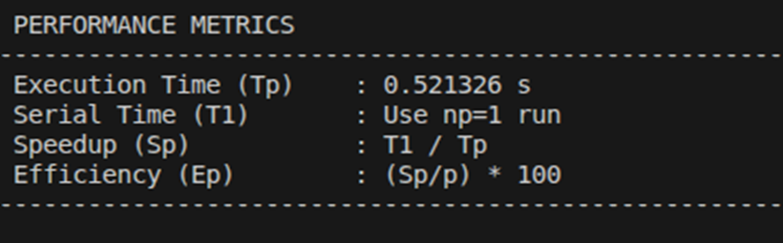

GRAPH:
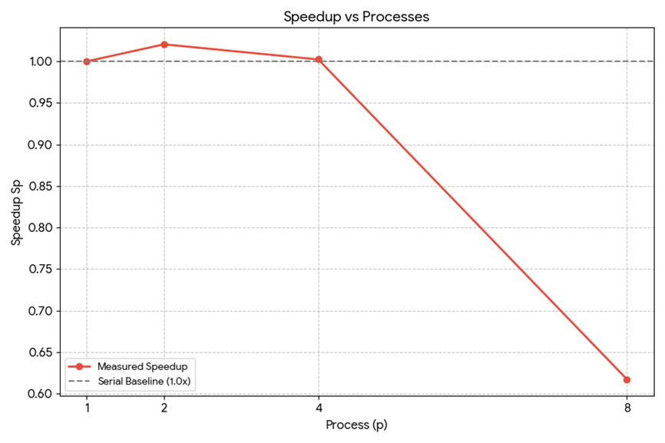

Conclusion
The performance analysis of the ring communication program shows that increasing the number of processes did not significantly improve execution time. While a slight speedup was observed at p=2, performance remained almost the same at p=4 and degraded at p=8. The efficiency consistently decreased as the number of processes increased, indicating poor scalability.
Additionally, communication overhead increased sharply from 48.97% (p=2) to 92.27% (p=8). This indicates that most of the execution time at higher process counts is spent on communication and synchronization rather than computation. Since the workload is replicated instead of being divided among processes, adding more processors does not reduce computation time. Therefore, the program demonstrates limited parallel efficiency and high communication overhead at larger process counts.

Exercise 2: Parallel Array Sum
Objective: Write an MPI program to compute the sum of a 100-element array in parallel. Distribute the array using MPI_Scatter, compute local sums, then combine with MPI_Reduce. The expected global sum is 5050 (sum of 1 to 100), and the average is 50.5.

Results
Process (p) | Time Tp​ (s) | Speedup Sp​ | Efficiency Ep​ (%) | Communication (%)
1 | 0.00000508 | 1.0000 | 100.00 | 0.00
2 | 0.00000804 | 0.6318 | 31.59 | 68.41
4 | 0.00003415 | 0.1488 | 3.72 | 96.28
8 | 0.00009091 | 0.0559 | 0.70 | 99.30

PERFORMANCE METRICS :
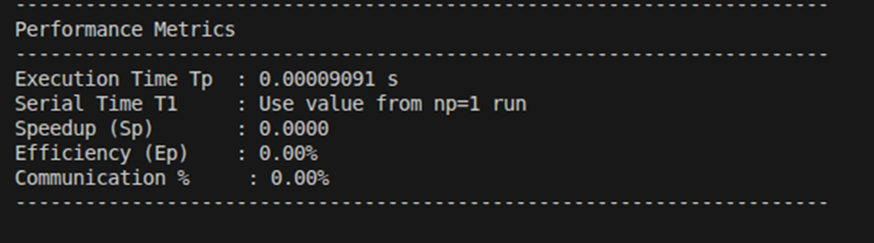

GRAPH :
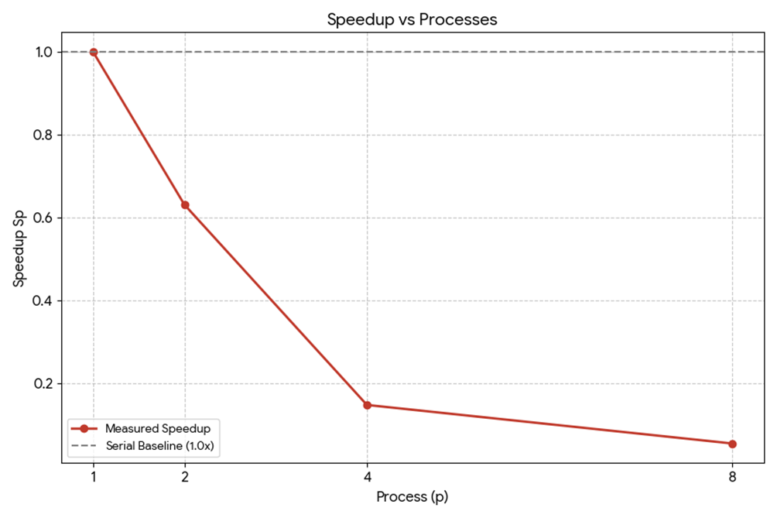

Conclusion
The parallel array sum program correctly computed the global sum of the array (5050) and verified the average value (50.50) for all process counts. However, performance analysis shows that increasing the number of processes did not improve execution time.
For p=2,4 and 8, the speedup remained less than 1 and efficiency decreased drastically. Communication overhead increased significantly, reaching almost 99% at p=8. This behavior occurs because the array size (100 elements) is very small, so computation time is negligible compared to MPI communication and synchronization overhead. As a result, adding more processes increases overhead instead of improving performance. Thus, for small problem sizes, parallelization is inefficient and may degrade overall performance.

Exercise 3: Finding Maximum and Minimum
Objective: Each process generates 10 random numbers (0–1000), finds its local max and min, then MPI_Reduce with MPI_MAXLOC and MPI_MINLOC is used to find the global extremes along with the rank of the process that held them.

Results
Process (p) | Time Tp​ (s) | Speedup Sp​ | Efficiency Ep​ (%) | Communication (%)
1 | 0.00000446 | 1.0000 | 100.00 | 0.00
2 | 0.00002494 | 0.1789 | 8.95 | 91.05
4 | 0.00007835 | 0.0569 | 1.42 | 98.58
8 | 0.00009862 | 0.0452 | 0.56 | 99.44

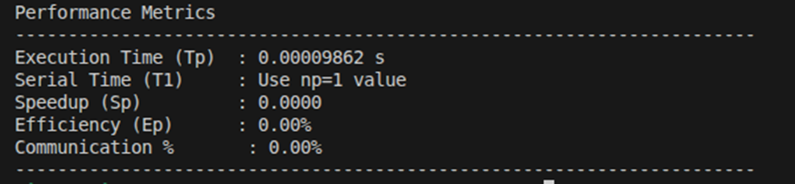

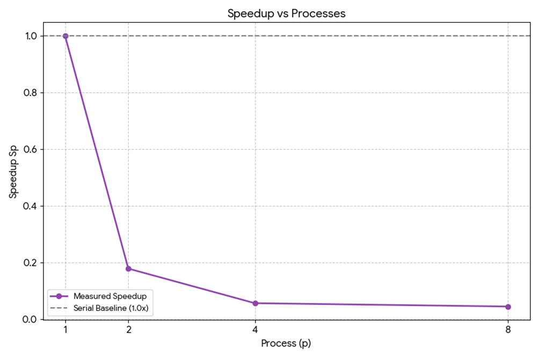

Conclusion
The MPI program successfully computed the global maximum and minimum values across all processes and correctly identified the processes that produced these values using MPI_MAXLOC and MPI_MINLOC. The results were accurate for all tested process counts (1, 2, 4, and 8).
However, performance analysis shows that increasing the number of processes did not improve execution time. The speedup remained less than 1 and efficiency decreased significantly as the number of processes increased. Communication overhead rose sharply, reaching more than 99% for higher process counts. This behavior occurs because each process only generates and processes 10 random numbers, resulting in extremely small computation time. Therefore, MPI communication and synchronization overhead dominate the total execution time. Hence, for very small workloads, parallelization is inefficient and may degrade performance rather than improve it.

Exercise 4: Parallel Dot Product
Objective: Compute the dot product of vectors A = [1,2,3,4,5,6,7,8] and B = [8,7,6,5,4,3,2,1] in parallel. MPI_Scatter distributes both vectors, each process computes a partial dot product, and MPI_Reduce collects the final sum. The expected result is 120.

Results
Process (p) | Time Tp​ (s) | Speedup Sp​ | Efficiency Ep​ (%) | Communication (%)
1 | 0.00000465 | 1.0000 | 100.00 | 0.00
2 | 0.00002540 | 0.1831 | 9.16 | 90.84
4 | 0.00005848 | 0.0795 | 1.99 | 98.01
8 | 0.00008957 | 0.0519 | 0.65 | 99.35

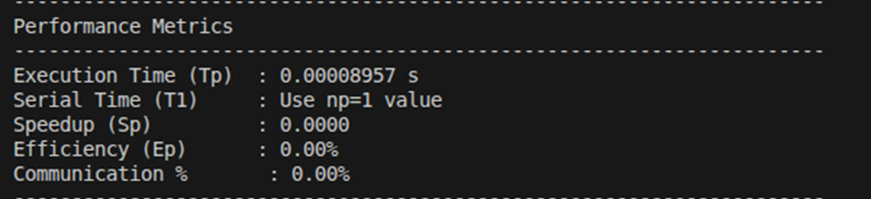

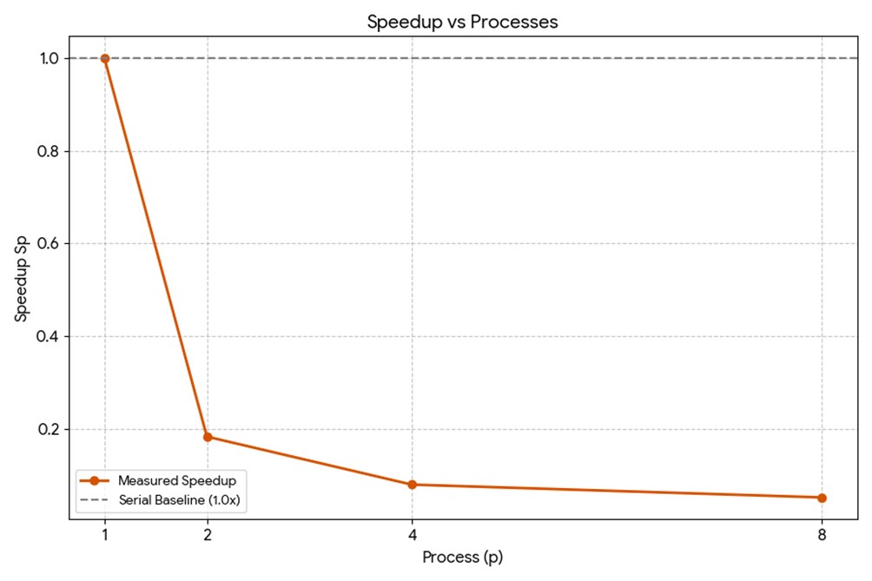

Conclusion
The parallel dot product program correctly computed the result (120) for all tested process counts (1, 2, 4, and 8), confirming the correctness of the MPI implementation using MPI Scatter and MPI Reduce.
However, performance analysis shows that increasing the number of processes did not improve execution time. The speedup remained less than 1 for p>1, and efficiency decreased significantly as the number of processes increased. Communication overhead rose sharply, exceeding 90% for higher process counts. This occurs because the vector size (8 elements) is very small, making computation time negligible compared to MPI communication and synchronization overhead. As a result, parallelization becomes inefficient for such small problem sizes. Therefore, effective parallel performance requires sufficiently large workloads so that computation time dominates communication overhead.

